Unit 4 Results

4.1:
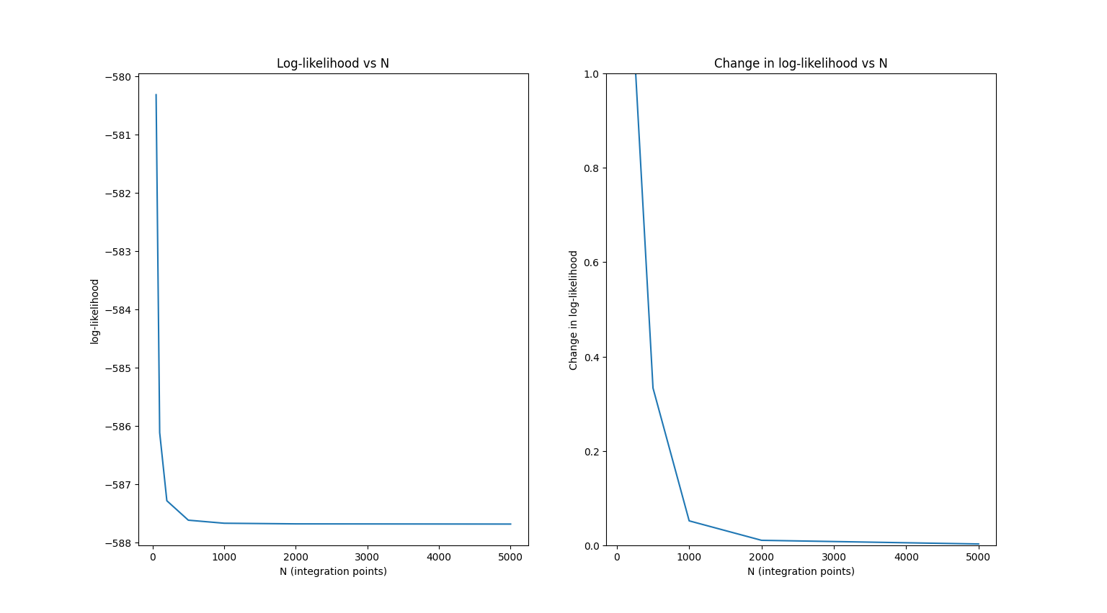
An N value of 2500 is chosen for the rest of this unit. The graphs show that at N=2500, the change in log-likelihood small compared to 1 and flattens out indicating convergence. Also, by minimising N, the efficiency of the program is increased. Increasing N past 2500 only serves to increase run time and creates no meaningful gain in accuracy.

4.2:
The scipy.optimize.minimize function returns an object with information related to the function that is being minimized. It outputs the following:
- if the optimiser was successful (True or False)
- the value of the function at its minimum (maximum in this case due to using the negative log-likelihood, maximising log-likelihood = minimising negative log-likelihood)
- the best fit parameters (H0, Omega_m, Omega_lambda)
- the number of iterations preformed
- the gradient of the solution, and the number of times the gradient was evaluated
- the number of function evaluations preformed
- the inverse of the hessian matrix at the solution point

The best fitting parameters are: [71.62945601 0.308 0.7155745 ]
The value of the function at this point is: 518.0980495043167
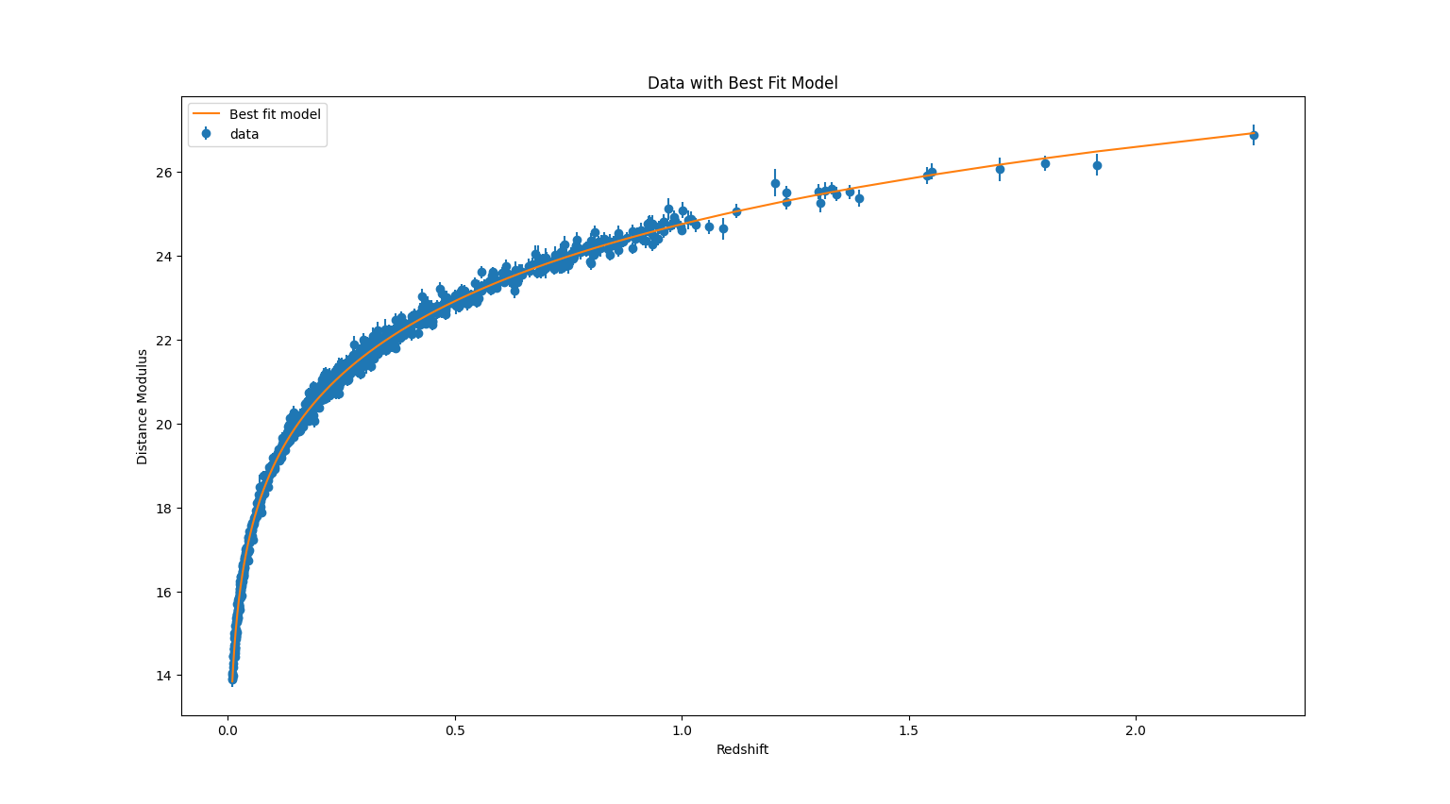
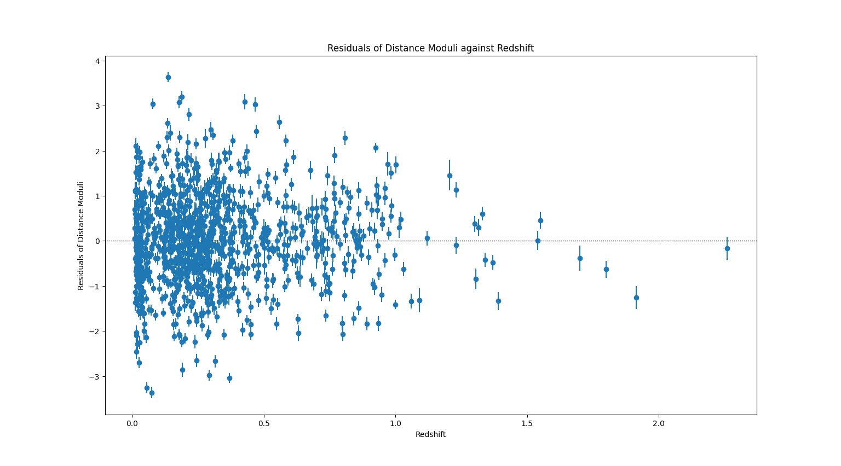
Mean of residuals: 0.015123215188779892
Standard deviation of residuals: 0.9942374104687774

4.3:
Best-fit parameters for standard: [71.62945601 0.308 0.7155745 ]
Best-fit negative log-likelihood for standard: 518.0980495043167
Best-fit parameters for no_lambda: [67.3806044 0.308 ]
Best-fit negative log-likelihood for no lambda: 698.0251003203481
The standard model has a lower negative log-likelihood and therefore a higher log-likelihood, meaning it is the better fit for the data.
Omega_m is unchanged between both models and H0 is reduced in the no lambda model.

